PayPal SFRA QA

**Question: How are the orders to be checked in PayPal as buyer and facilitator?**

**Answer:**

* In development environment, buyers and sellers can check order details in Paypal Sandbox via link <https://www.sandbox.paypal.com/uk/signin>
* As buyer (end customer), after login to the account, the transactions(orders) can been seen in summary and activities pages as shown below.

Note: Pending means order still under authorisation but not captured. Completed means capture has been triggered by seller.

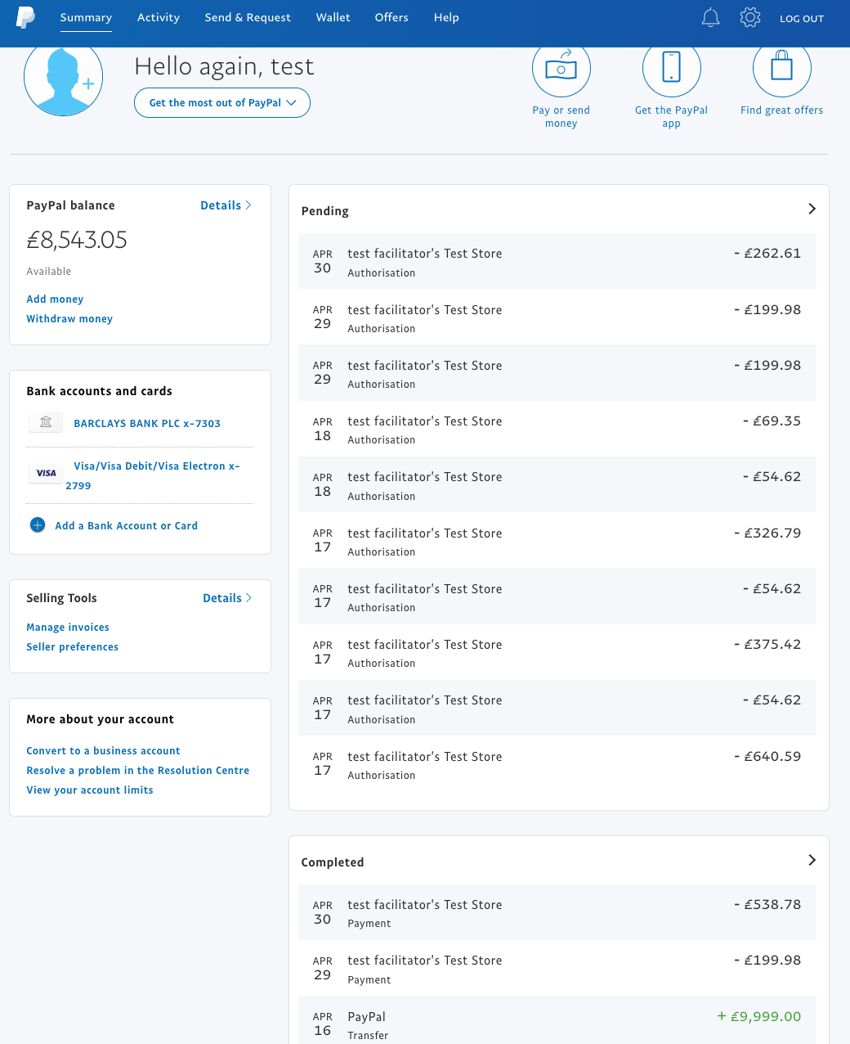

* As Seller (business company), transactions (orders) can been seen in summary and activities pages as shown below.

Summary page:

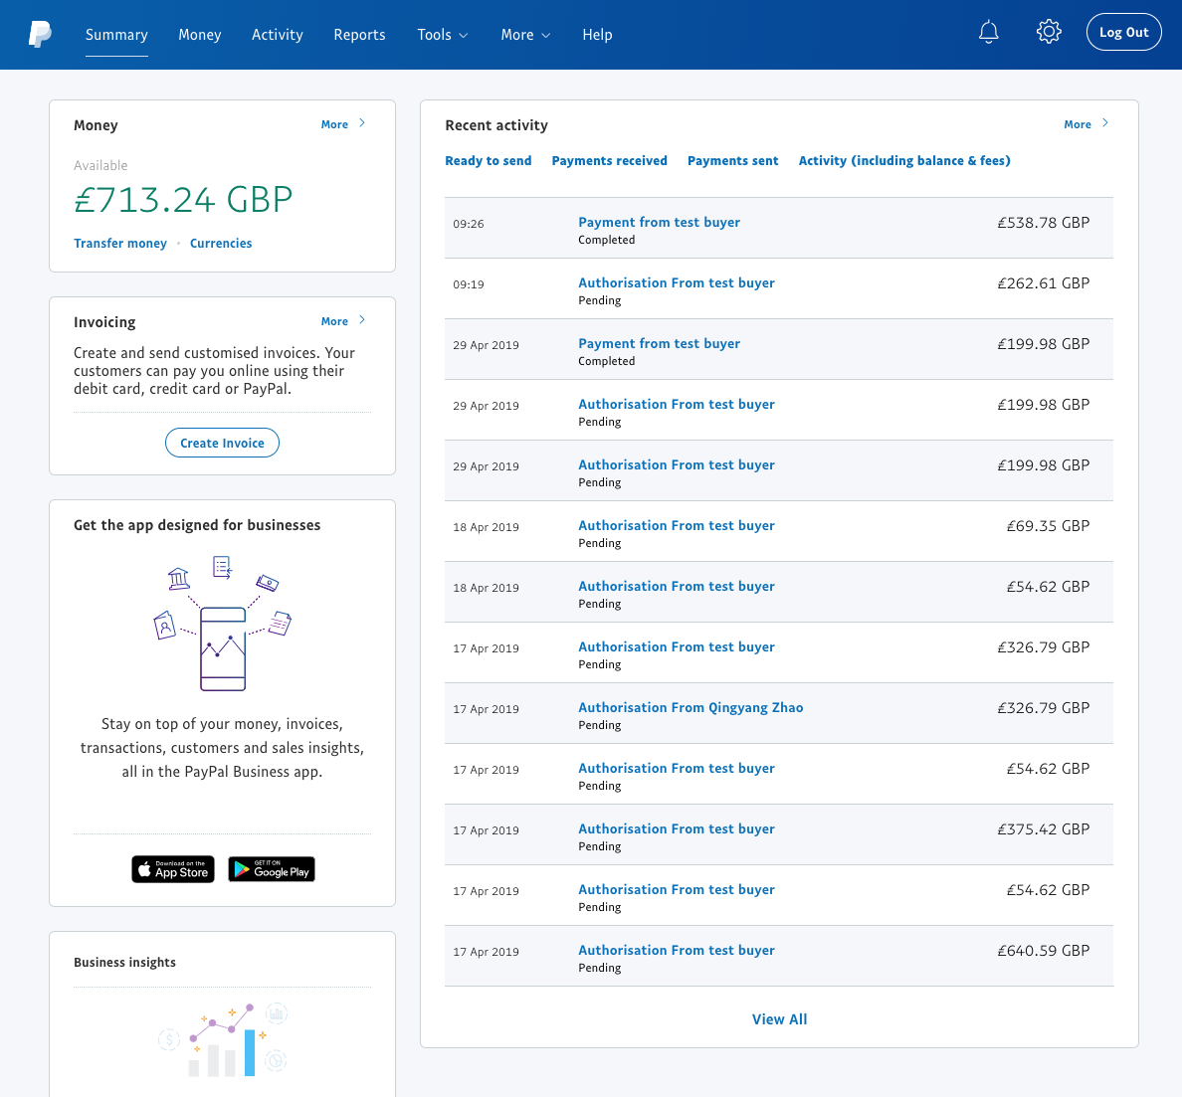

Activity page:

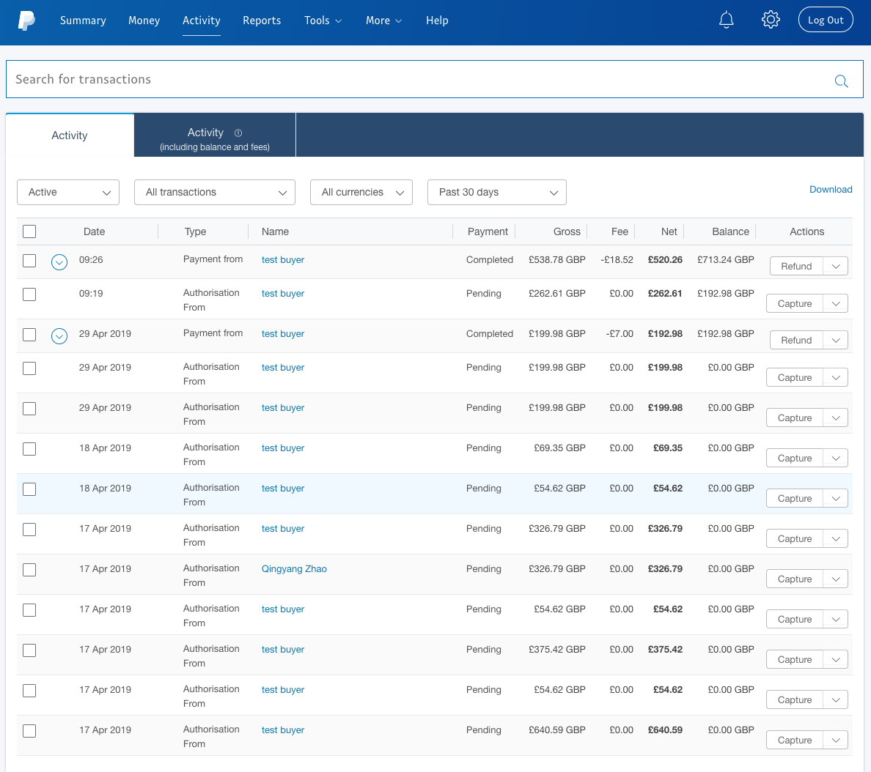

**Question: What level of orders details could be seen in PayPal?**

**Answer:**

* In buyer’s account, click on specific transaction, following details can be seen:
  + Payment method (balance, credit card), on commerce cloud it is PAYPAL
  + Shipping address information
  + Product name & description & line total amount
  + order number (Invoice ID on PayPal)
  + Order subtotal, shipping cost, order total amount

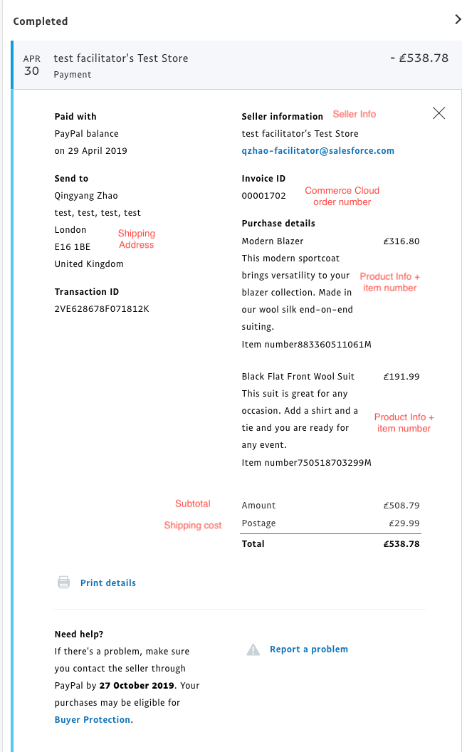

**Question: Does checkout process modification affect card authorisation?**

**Answer:**

Short answer is **NO.** This is because authorisation happens when the order finally placed & confirmed. In cart or checkout PayPal is only doing card verification, no transaction happens until final order placement.

**Question: How capture can be triggered?**

**Answer:**

The capture action can be triggered by seller account from PayPal portal (activity page -> Actions) against each authorisation transaction. Once it is done, buyer can see the transaction is in complete section

Seller Account:

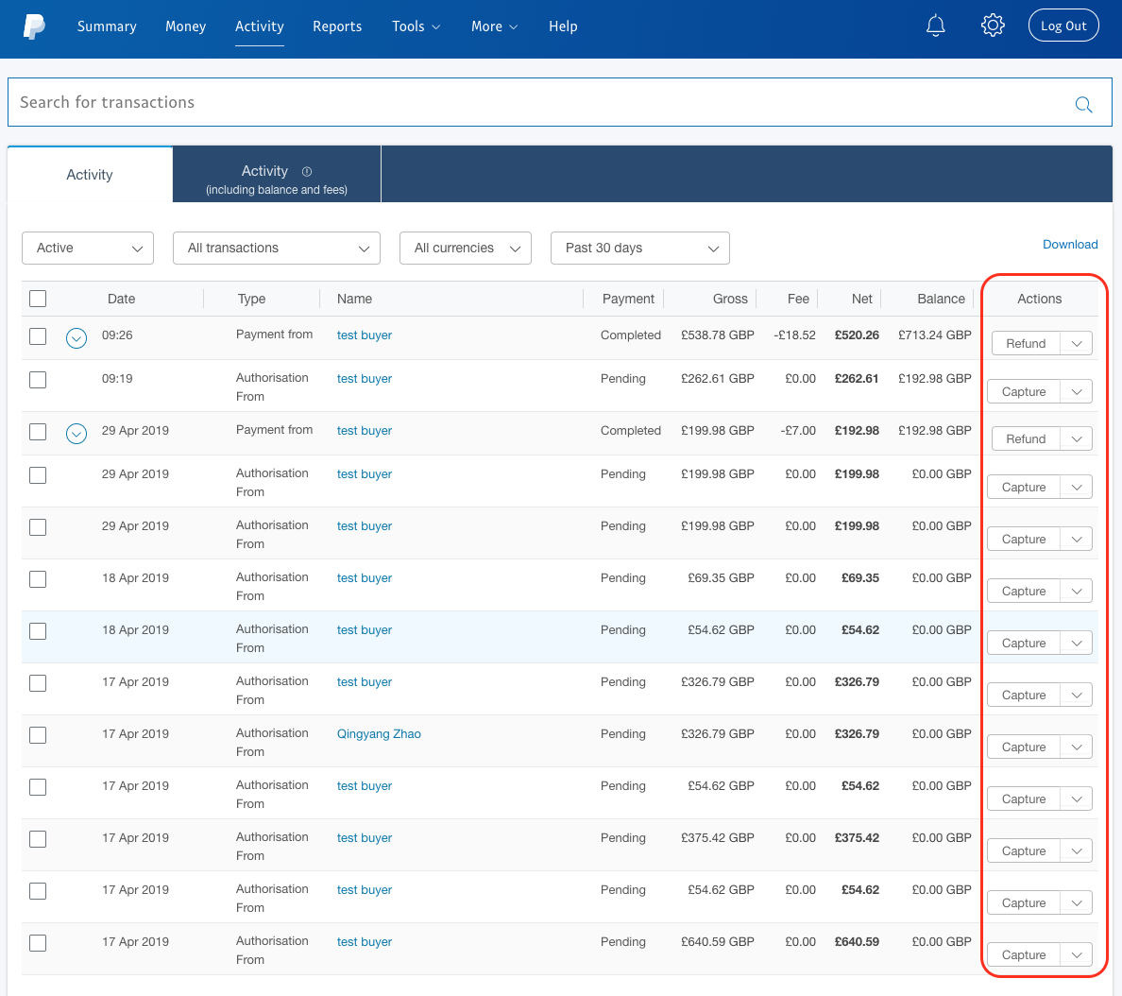

Buyer account:

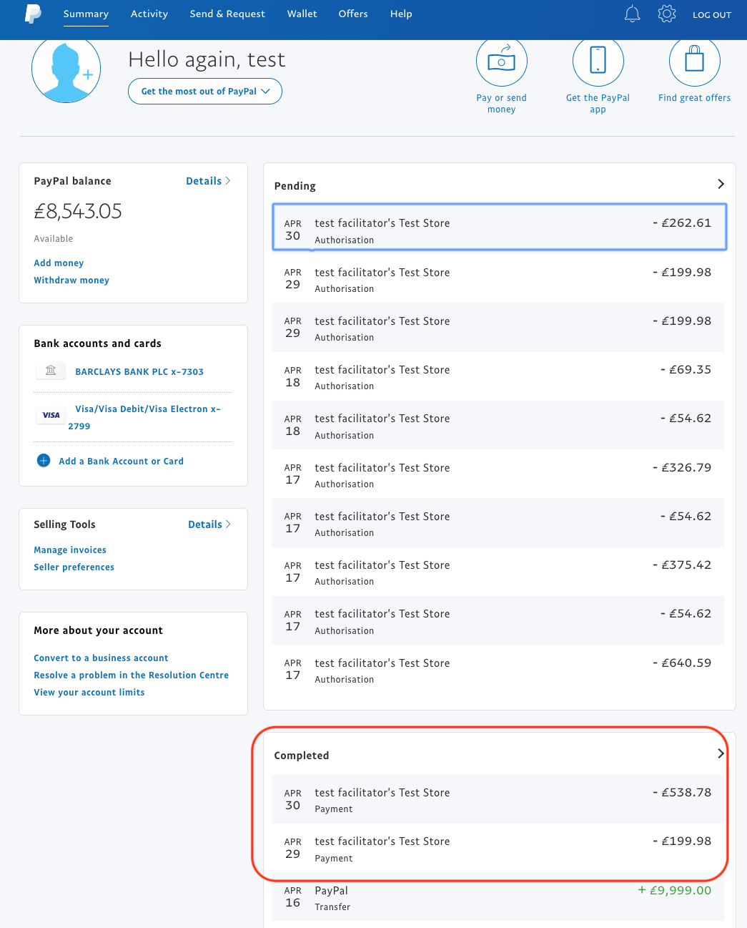

**Question: Is Commerce Cloud aware of capture action?**

**Answer:**

Unfortunately no, this is the gap to be closed by development, after capturing triggered from paypal, commerce cloud still shows order not paid.